

**INTRODUCTION This Global Air Transportation Network dataset is a comprehensive collection of information on airports, airlines and their routes. It contains information such as names, cities, countries, codes (IATA and ICAO) longitudes, latitudes and altitudes of airports across the world with detailed time zone and daylight saving time data. Additionally, this includes information about airlines including their IDs, name aliases, IATA and ICAO codes, callsigns country of origin and active/inactive status EMPATHY MAP**

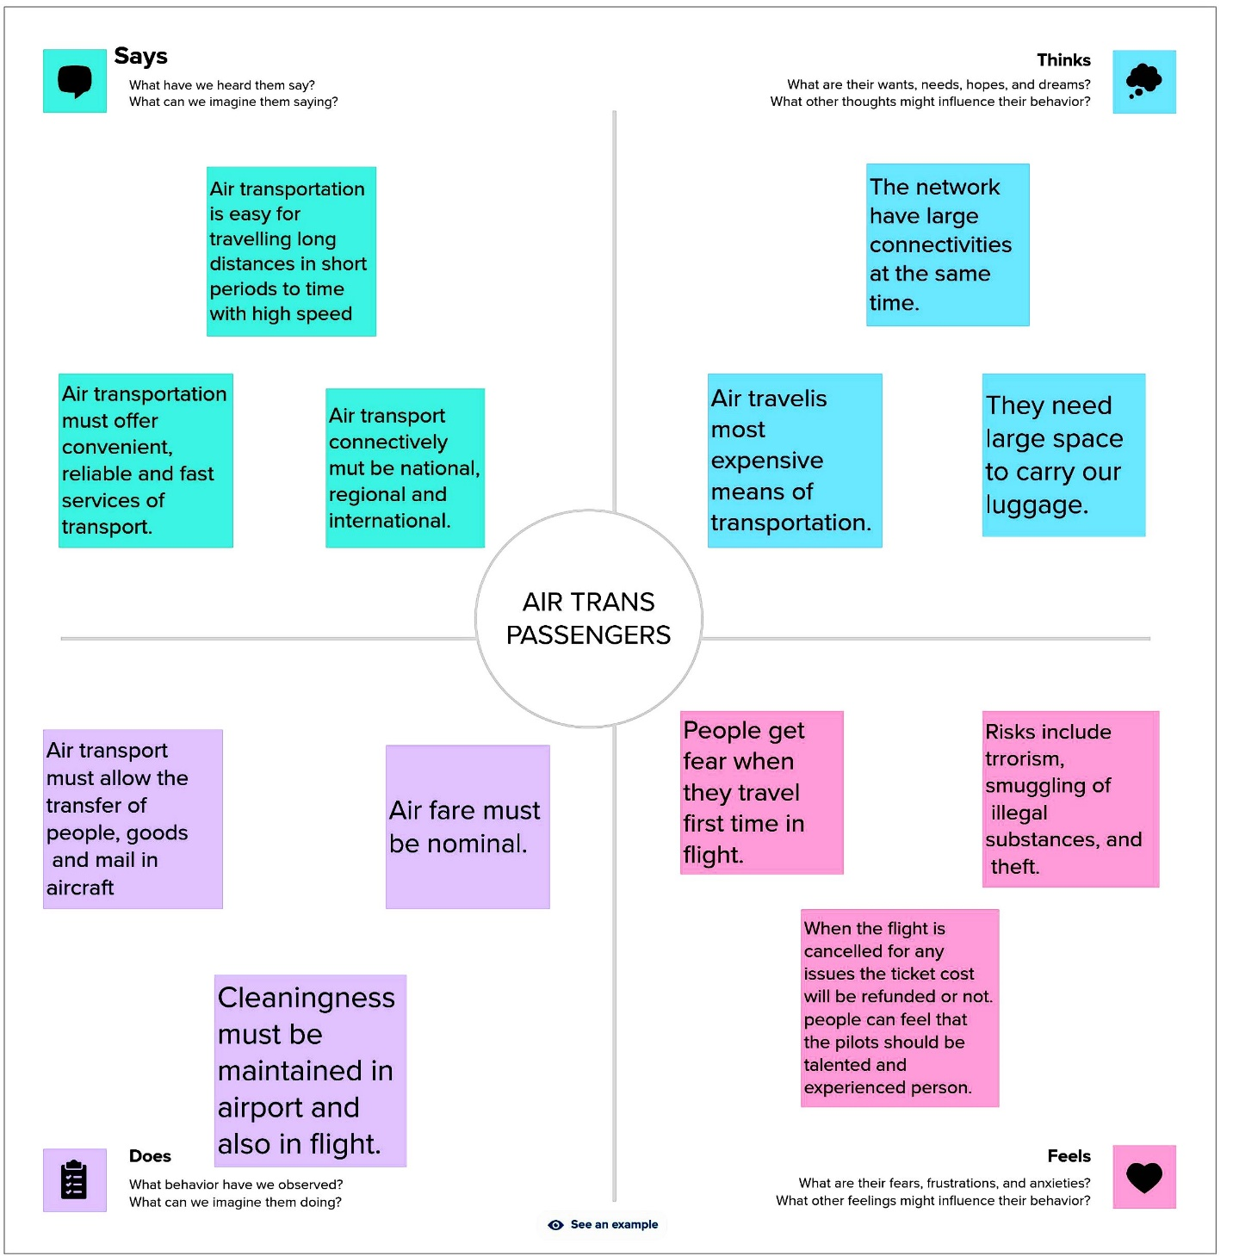

**BRAINSTROMING MAP**

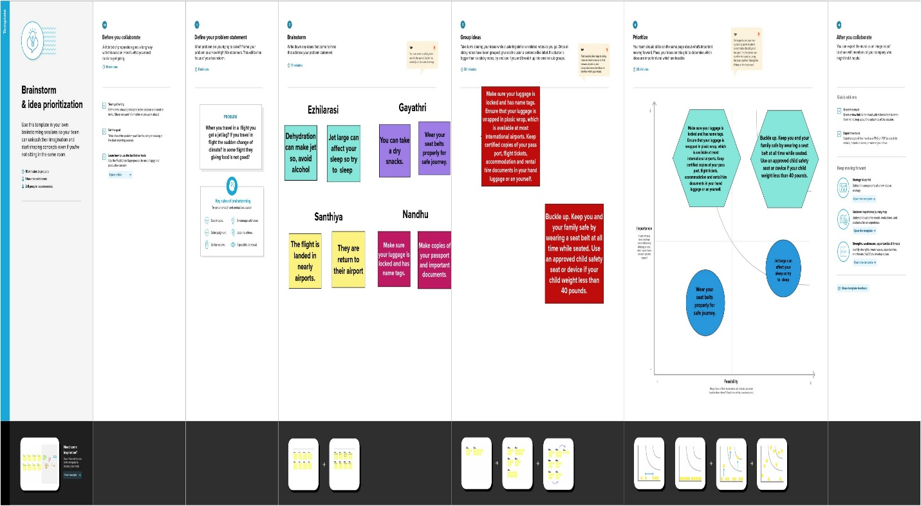

**RESULT**

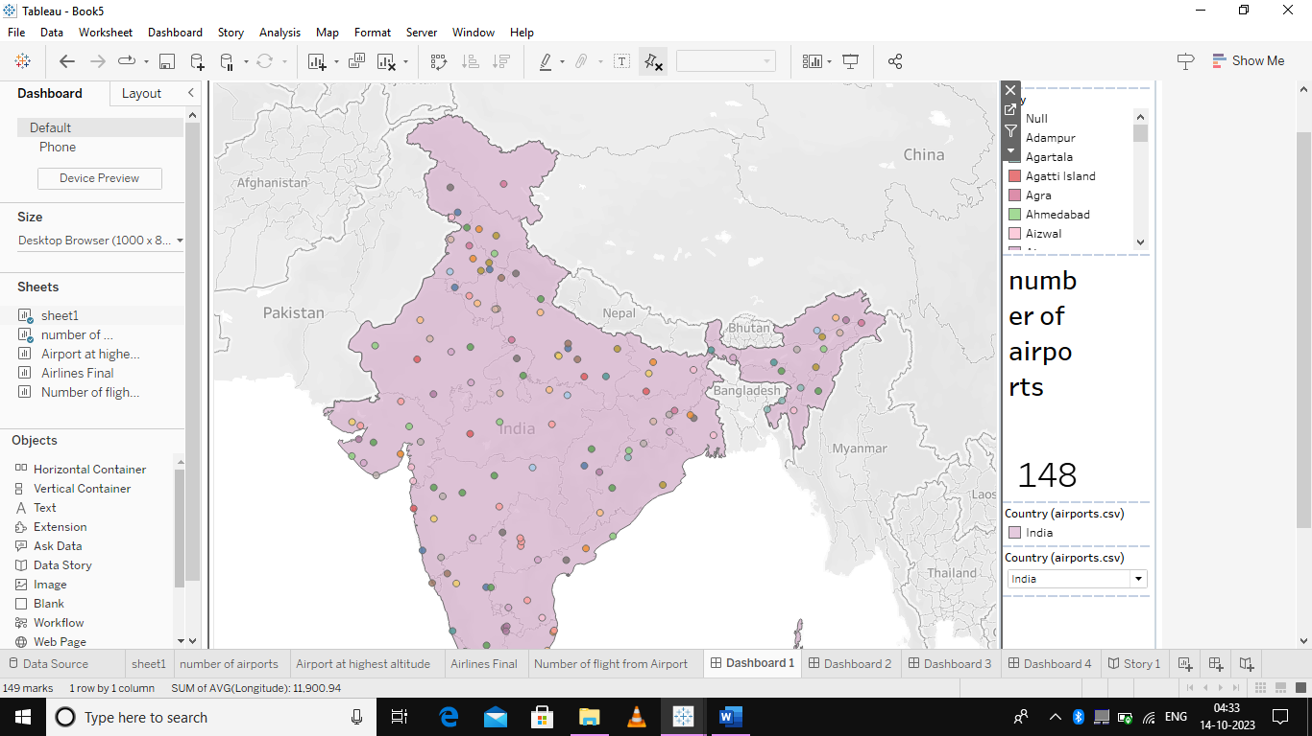

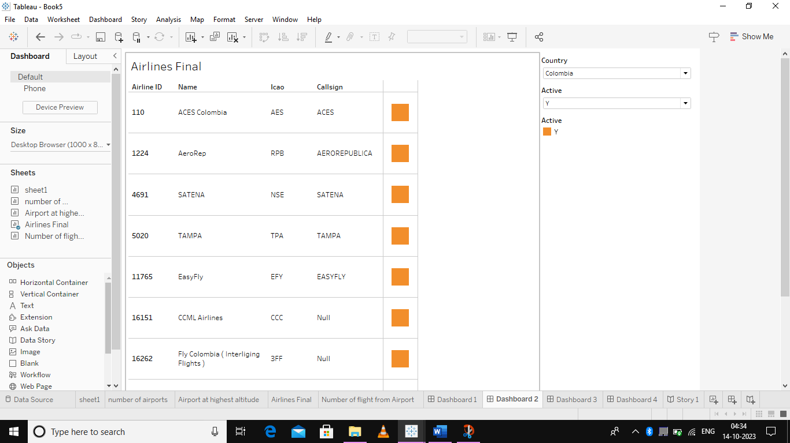

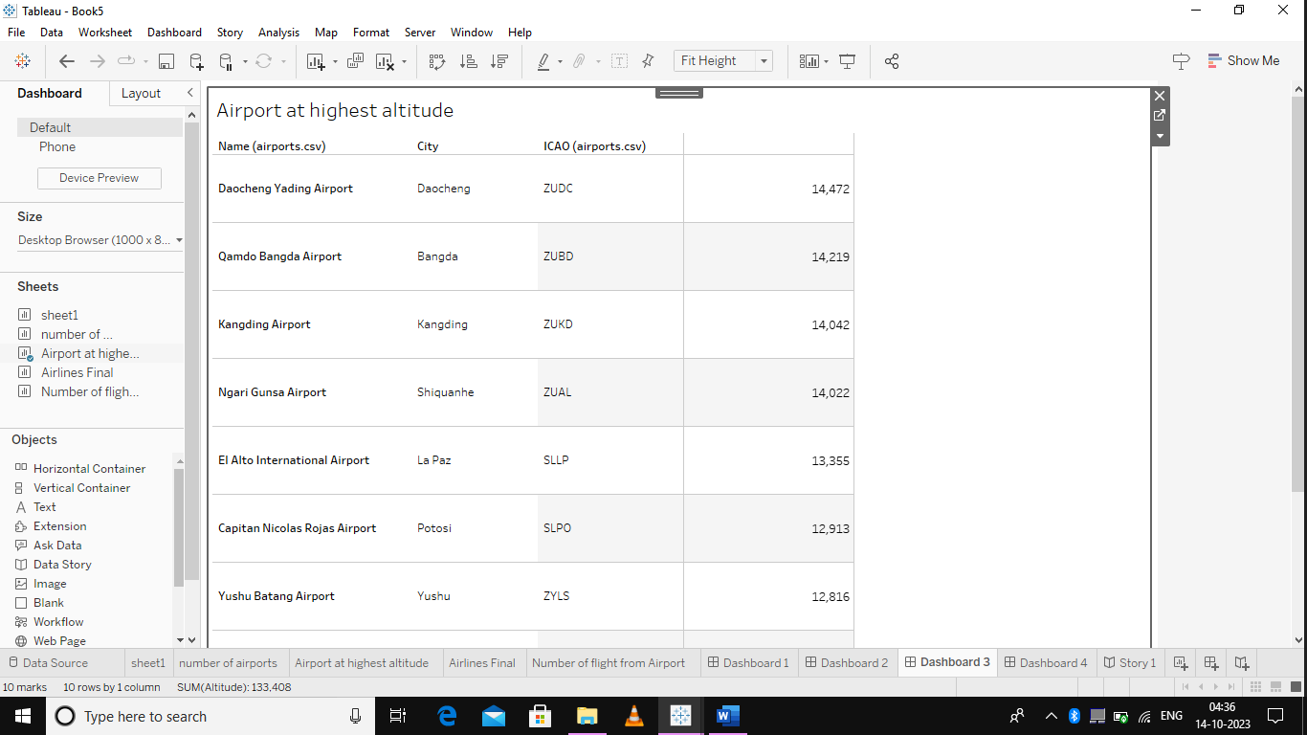

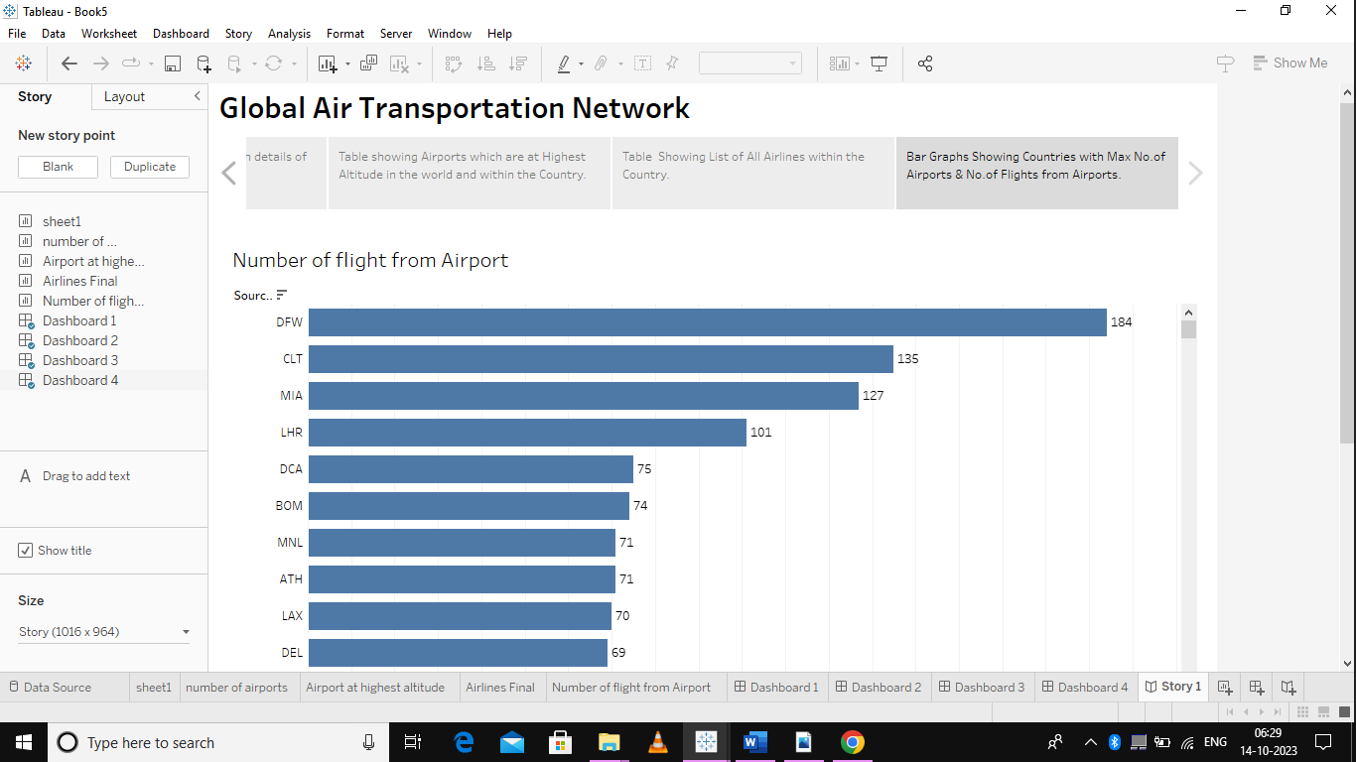

**ADVANTAGES AND DISADVANTAGES**

**ADVANTAGES Global Reach. Reliable Timelines. Reduced Inventory Holding Costs. Enhanced Security. DISADVANTAGES Higher Cost. Limited Capacity. Restrictions on Hazardous Goods.**

**APPLICATION**

Modeling air transport networks aims airline companies to organize their routes in a cost-efficient way and therefore maximize their profits. Air transport network models are also the tool to investigate system robustness. They help to determine weaknesses of the system in case of various kinds of disruptions. Once weaknesses are determined, a substitute node which can support all or part of the traffic load can be identified through the alternative strength for the pair. An alternative application is modeling human disease networks. Air transport network is used by millions of people every day, therefore it plays key role in the spread of some infections, such as influenza or SARS. In this sense air transport network is a transmitter similar to sexual networks, which is liable for the spread of AIDS and other sexually transmitted diseases.

**CONCLUSION**  In conclusion, the Indian aviation industry has undergone significant developments and growth in recent years. The expansion of regional connectivity, emergence of low- cost carriers, increased investment in infrastructure, and adoption of technological advancements have all contributed to the growth of the industry. **FUTURE SCOPE** The World Economic Forum proposes that the deployment of these private sector and government innovations to address mobility challenges can contribute to an improved mobility landscape – if they are deployed in a coordinated and collaborative way that aims to optimize the entire transport system. Unfortunately to date, these efforts in many instances may be exacerbating transport issues, most notably by adding congestion and complexity while also creating inefficiencies between public and private modes of transport

**Thank you**